# Existing Fingerprinting Integration

At the individual site level, iSanté supports the following two use cases:

1) Search via fingerprint (verification of identity). Patient swipes either middle finger and if her fingerprints already exist at the site, iSanté cover page for the patient is displayed.

2) Enter fingerprints as part of patient registration. Once patient is issued an iSanté ID, the patient swipes both middle fingers and these are stored in the fingerprint database with the ID.

These use cases can be best understood via the following screen shots:

1) Search via fingerprint (patient verification):

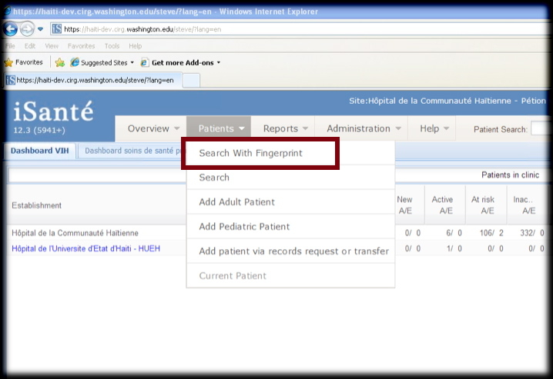

1.1) Obtain swipe:

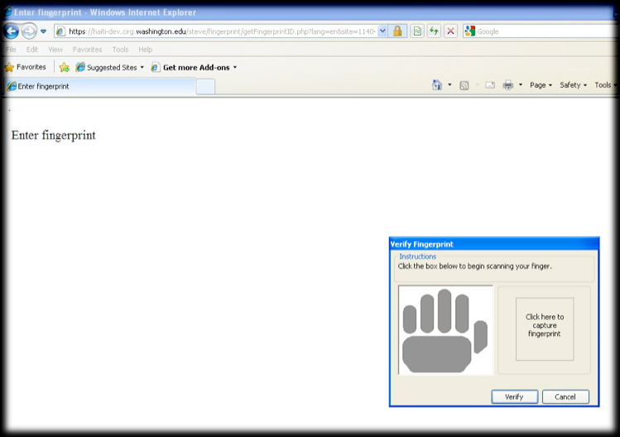

1.2) Display patient cover page if found via print; patient header shows a print image [this is now displayed on the left]:

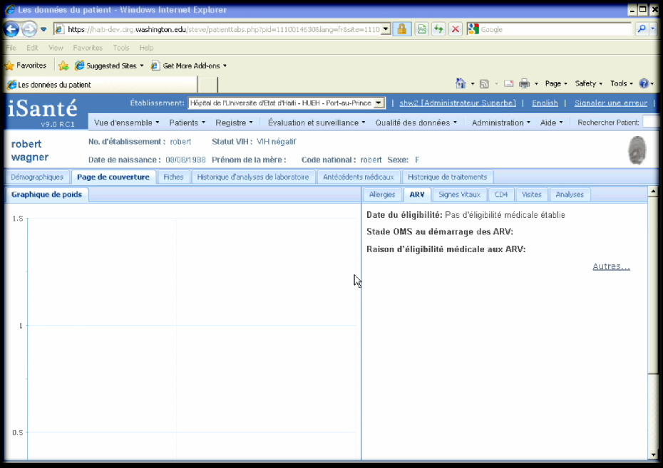

2) Enter [Add] fingerprints:

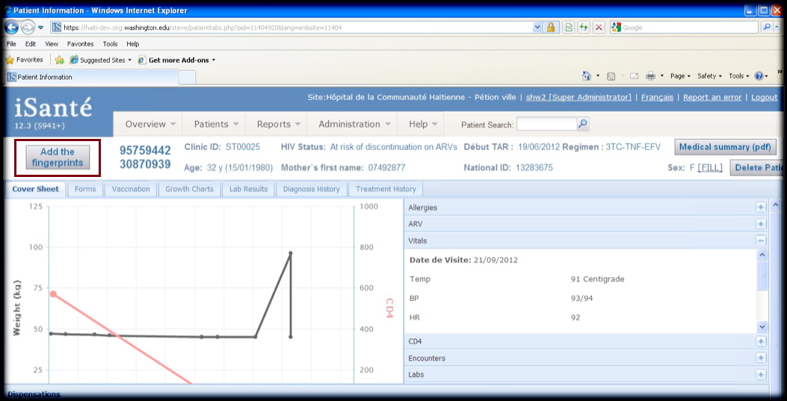

2.1) Swipe and save both middle fingers:

